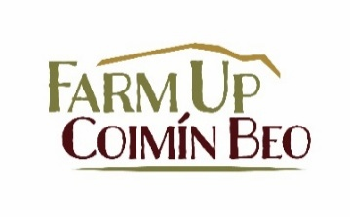

Farming And Restoration Management for Upland Commonages (FARM-Up)

Expression of Interest Form
To express your interest in participating in the FARM-Up EIP, please fill out your details below. Please return the completed form by post to FARM-Up EIP, South West Mayo Development Company, I.P.I. Centre, Breaffy Road, Castlebar, Co. Mayo, F23 V125. Alternatively you can scan the completed form and email to jwalsh@southmayo.com. The closing date is Friday 13th March 2026.

- I wish to express my interest in joining the FARM-Up EIP, a four-year agri-environmental initiative focused on commonage management and restoration in counties Mayo (Nephin area / Clew Bay coastline) and Donegal (An Earagail).
- I authorise the FARM-Up Project Team to access my herd number, land parcel information, and agri-environmental scheme participation from Department of Agriculture, Food and the Marine (DAFM) records to assess eligibility and administer the program.
- I authorise the FARM-Up Project Team to access my Agri-Climate Rural Environment Scheme (ACRES) data from the relevant ACRES Co-operation teams, including but not limited to ACRES Results Based Payment Scheme participation, Results Based Payment Scheme scores, parcel information, landscape actions, non-productive investments and any other relevant information to assess eligibility and administer the program.
- I understand that my data will be held securely and used only for the purposes of project administration, in line with GDPR.
- I acknowledge that participation is voluntary and that submitting this form does not guarantee selection for the program.
- I understand the scope and objectives of the project and that involvement will require active participation such as identifying commonage management challenges and developing solutions and recommendations with the support of the FARM-Up project team, this can include attending workshops, training events, demonstration events and other activities.
- I will commit to responding to a simple questionnaire on my farming system and ACRES participation.
Please use BLOCK CAPITALS when completing your details below
NAME(S): |  | FARM ADVISOR  NAME:  PHONE:
ADDRESS: |  | FARM ADVISOR  NAME:  PHONE:
PHONE: |  | EMAIL ADDRESS:
HERD NUMBER:
EMAIL ADDRESS:
SIGNED: |  | FOR OFFICE USE ONLY
DATE:

